**VLAN Trunking Protocol (VTP) Configuration**

**Designed Topology:**

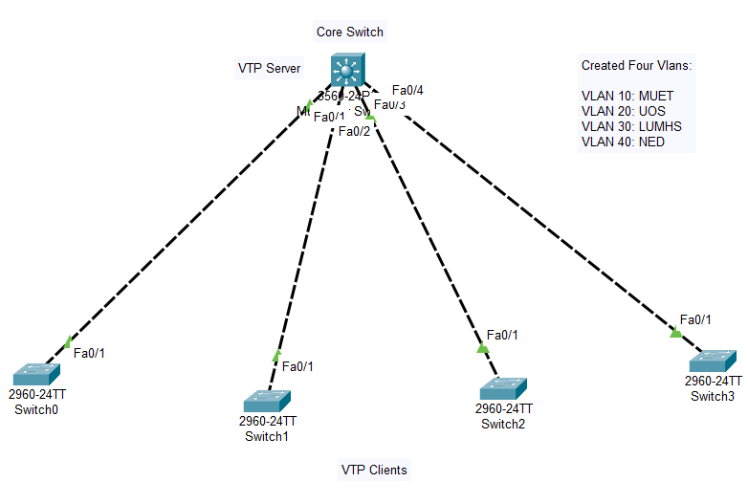

**Configuration of Core Switch:**

Switch>enable

Switch#config terminal

Switch(config)#int fa0/1

Switch(config-if)#switchport trunk encapsulation dot1Q

Switch(config-if)#switchport mode trunk

Switch(config-if)#exit

Switch(config)#int fa0/2

Switch(config-if)#switchport trunk encapsulation dot1Q

Switch(config-if)#switchport mode trunk

Switch(config-if)#exit

Switch(config)#int fa0/3

Switch(config-if)#switchport trunk encapsulation dot1Q

Switch(config-if)#switchport mode trunk

Switch(config-if)#exit

Switch(config)#int fa0/4

Switch(config-if)#switchport trunk encapsulation dot1Q

Switch(config-if)#switchport mode trunk

Switch(config-if)#exit

Switch(config)#vtp mode server

Switch(config)#vtp domain Admin

Switch(config)#vlan 10

Switch(config-vlan)#name MUET

Switch(config-vlan)#exit

Switch(config)#vlan 20

Switch(config-vlan)#name UOS

Switch(config-vlan)#exit

Switch(config)#vlan 30

Switch(config-vlan)#name LUMHS

Switch(config-vlan)#exit

Switch(config)#vlan 40

Switch(config-vlan)#name NED

Switch(config-vlan)#exit

Switch(config)#ip routing

Switch(config)#exit

Switch#write

**Configuration of Switch0:**

Switch>enable

Switch#config terminal

Switch(config)#hostname SW0

SW0(config)#vtp mode client

SW0(config)#vtp domain Admin

SW0(config)#exit

SW0#write

**Configuration of Switch1:**

Switch>enable

Switch#config terminal

Switch(config)#hostname SW1

SW1(config)#vtp mode client

SW1(config)#vtp domain Admin

SW1(config)#exit

SW1#write

**Configuration of Switch2:**

Switch>enable

Switch#config terminal

Switch(config)#hostname SW2

SW2(config)#vtp mode client

SW2(config)#vtp domain Admin

SW2(config)#exit

SW2#write

**Configuration of Switch3:**

Switch>enable

Switch#config terminal

Switch(config)#hostname SW3

SW3(config)#vtp mode client

SW3(config)#vtp domain Admin

SW3(config)#exit

SW3#write

**Displaying information about the current status of VTP:**

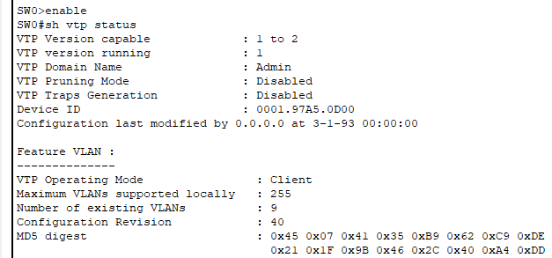

**Displaying information about the configured VLANs:**

